# User Manual

1. Create database – Copy paste data/database.sql into cmd mysql.

The database name is “projectdb”. Type “use projectdb;”.

The three tables are below: 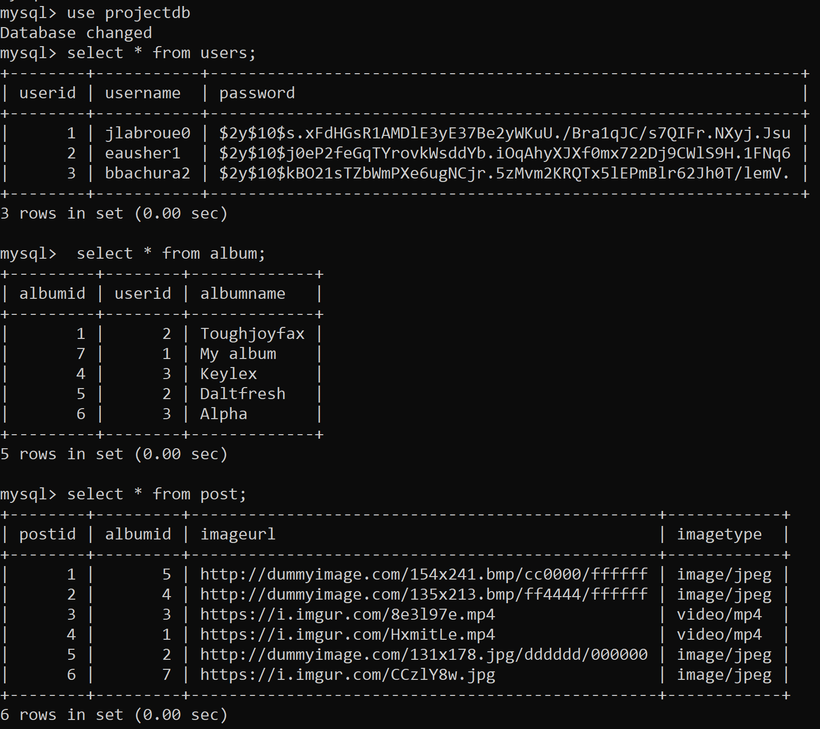

1. Open “The two.php” - Login with username (example: jlabroue0)and password (example: vc5PBMQ) from “users” table.

1. After login with correct username and password, the main page shows 6 buttons.

* Log out

Return to Login page and can not return this page.

* View Trendy Post

Shows latest 30 images from imgur.com by API

If you like the image, you can click “save to my album” to save this image into one of your album.

System lists all your album name as radio button and ask you which album you want to add. Choose one and click add.

* Create new album

After click “create new album” button, page shows textbox. User can input new album name and click create.

* Delete your albums

After click “delete your albums” button, page radio buttons with user’s albums’ name. User can choose one album and click delete.

* Edit your albums

After click “edit new album” button, page shows radio buttons with your albums name and textbox. User can choose one album and input new name for it and click edit.

* Show my albums

Go to album page which has radio buttons with user’s album names, check albums, go back and log out buttons.

* If you choose one radio button and click check album, the page will list all images you have chosen into this album.

* If you choose “go back” button, the page will go back to previous main page.
* If you choose “log out” button, the page will go to login page and can not return.